**Project report on**

**"Fire Alarm Circuit”**

**For**

**1EC101**

**Electronics Devices & Circuit**

**B. Tech. Semester III**

### Report Prepared By

#### DIVYANSHU KALAL

**(23BEC053)**

#### &

#### DULAR SARODIA

**(23BEC056)**



**School of Engineering**

**Institute of Technology**

**Nirma University**

**Ahmedabad 382481**

**Nov 2024**

**Index**

|  |  |
| --- | --- |
| **Sr. No** | **Description** |
| **1.** | **Introduction** |
| **2.** | **List of Components** |
| **3.** | **Circuit Diagram** |
| **4.** | **Working of Circuit** |
| **5.** | **Applications** |
| **6.** | **Conclusion** |

1. INTRODUCTION

The Fire Alarm Circuit is a basic temperature-sensitive alarm system that provides an audible alert in case of fire or high temperatures. Using a 555 Timer IC and a thermistor, this project showcases how simple electronic components can be combined to create an effective safety device. The circuit is adjustable to detect temperature thresholds, making it suitable for various applications.

2. LIST OF COMPONENTS

|  |  |  |
| --- | --- | --- |
| Component | Specification / Value | Quantity |
| 555 Timer IC | NE555 | 1 |
| NPN Transistor | BC547 | 1 |
| Thermistor | 10kΩ | 1 |
| Resistors | 100kΩ, 4.7kΩ, 1kΩ | 3 |
| Variable Resistor | 1MΩ | 1 |
| Capacitor | 10µF | 1 |
| Buzzer | Standard | 1 |
| Breadboard | Standard size | 1 |
| Battery | 9V | 1 |
| Connecting Wires | - | As needed |

**3. CIRCUIT DIAGRAM**

**4. Working of the Circuit**

The circuit operates as a fire alarm system based on temperature detection. The working is described in the following steps:

**4.1 Thermistor and Temperature Detection**

The thermistor (THM1) is a temperature-sensitive resistor.

When the temperature rises, its resistance decreases, causing a voltage change that triggers the transistor.

**4.2 Transistor as a Switch**

The NPN transistor (BC547) switches ON when the thermistor detects a temperature rise.

The transistor acts as a bridge, enabling the 555 Timer circuit.

**4.3 555 Timer in Astable Mode**

The 555 Timer IC generates a square wave signal in astable mode.

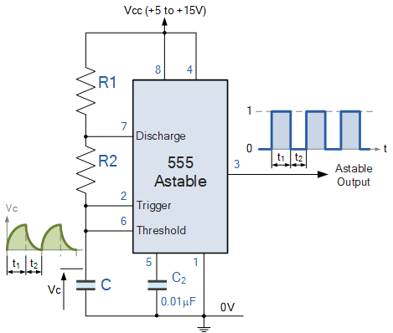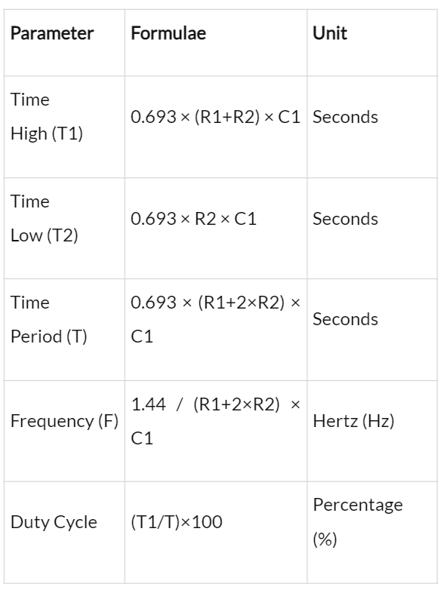

This signal activates the buzzer (B1), producing a continuous audible alarm.

**4.4 Adjustable Sensitivity**

The circuit's sensitivity is adjusted using the variable resistor (VR1).

This allows the user to set the temperature threshold for alarm activation.

**5. Applications**

This Fire Alarm Circuit can be used in various real-world scenarios, including:

* **Home and Office Safety:** Early fire detection systems to prevent accidents.
* **Industrial Use:** Monitoring temperature-sensitive areas like server rooms or chemical storage.
* **Educational Demonstration:** A practical project for understanding electronic components like thermistors and 555 Timer ICs.

6. CONCLUSION

The Fire Alarm Circuit successfully demonstrates the use of simple electronic components to create a functional safety device.

Key Learnings:

Understanding the interaction between the thermistor, transistor, and 555 Timer IC.

Practical skills in designing, assembling, and troubleshooting electronic circuits.

Insights into temperature-sensitive applications and fire safety measures.

Challenges Faced and Solutions:

Sensitivity Adjustment: Initial difficulty in calibrating the temperature threshold was resolved by fine-tuning the variable resistor.

Component Connections: Issues with loose connections on the breadboard were fixed by verifying each component placement.

This project has enhanced our practical knowledge of electronic circuits and their real-world applications.

By:-23BEC053 & 23BEC056